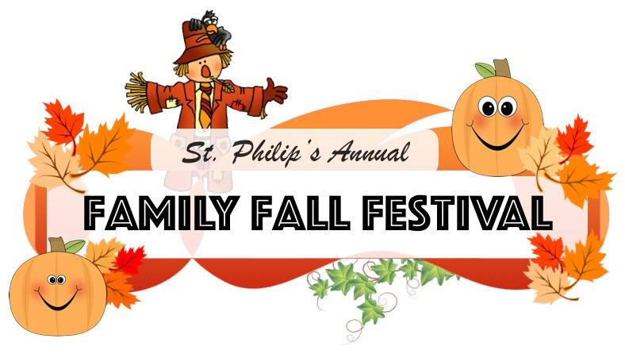

Loganville First UMC’s

Saturday October 26
6:00 – 8:00pm
FUN, FOOD, & FELLOWSHIP
For ALL AGES
Carnival Games and Prizes
Costume Contest!
FREE Popcorn!
Free Hot Dog and Drink*
*if you bring a canned food item.
221 Main Street Loganville
children@loganvillefumc.org 770-490-6967
“Where His SON shines, His children blossom!”

Loganville First UMC’s

Saturday October 26
6:00 – 8:00pm
FUN, FOOD, & FELLOWSHIP
For ALL AGES
Carnival Games and Prizes
Costume Contest!
FREE Popcorn!
Free Hot Dog and Drink*
*if you bring a canned food item.
221 Main Street Loganville
children@loganvillefumc.org 770-490-6967
“Where His SON shines, His children blossom!”

